FLIGHT BOOKING APP

INTRODUCTION:
The Flight Booking System is a comprehensive and user-friendly web application designed to streamline and automate the process of searching, comparing, and booking airline tickets. This system serves as a centralized platform where users can easily access flight information, check availability, and make reservations without the need to visit multiple airline websites or travel agencies.
The application is built using modern web technologies and follows a scalable architecture that ensures efficient performance and seamless user experience. It provides a wide range of functionalities including flight search, booking management, user authentication, and administrative controls.
Users can customize their search based on preferences such as departure location,
destination, travel date, and pricing. The system also ensures secure handling of user data through authentication mechanisms and data protection techniques.
Additionally, the Flight Booking System integrates various modules such as flight management, booking processing, and database storage to provide real-time results and
accurate information. Its flexibility, efficiency, and ease of use make it an ideal solution for travelers, airline service providers, and administrators seeking an efficient digital booking platform.

SCENARIO Based Case Study:
Meet Rahul, a working professional who frequently travels for business meetings across
different cities. Due to his busy schedule, Rahul prefers a fast and reliable way to book flight tickets without spending too much time searching across multiple platforms.
Rahul discovers the Flight Booking System, a web-based application designed to simplify
airline reservations. Curious about its features, he decides to explore how it can improve his travel planning experience.

User Registration and Authentication:
Rahul registers on the platform by providing his personal details such as name, email, and password. He logs in securely using his credentials, ensuring that his data remains protected.

Flight Search and Comparison:
Rahul searches for flights by entering his departure city, destination, and travel date. The system displays a list of available flights along with details such as airline name, departure time, arrival time, and ticket price. He compares multiple options and selects the most suitable one.

Booking Management:
After selecting a flight, Rahul proceeds to book his ticket by entering passenger details. The system confirms the booking and stores the information securely in the database.

Payment and Confirmation:
Rahul completes the payment process using secure payment methods. The system generates a booking confirmation along with ticket details.

Booking History and Tracking:
Rahul can view his previous bookings and track upcoming trips through his user dashboard.

Admin Interaction:
Meanwhile, the system administrator manages flight schedules, updates pricing, and monitors bookings to ensure smooth operation of the platform.

Rahul's Experience:
With the help of the Flight Booking System, Rahul can now plan his trips efficiently without

wasting time. The system simplifies the booking process, making it fast, convenient, and reliable.

SYSTEM REQUIREMENTS:
Software Requirements:
These are the essential tools and technologies required for developing and running the Flight Booking System efficiently. Each software component plays a specific role in building and maintaining the application.

Operating System
Windows 10/11, macOS, or Linux is required as it supports cross-platform development. It provides a stable environment for running development tools, servers, and databases.

Node.js (v16 or above)
Node.js is used as the backend runtime environment. It allows execution of JavaScript on the server side and is responsible for handling API requests, server logic, and communication
between frontend and database.

npm (Node Package Manager)
npm is used to install and manage dependencies required for the project. It helps developers easily add libraries such as Express, Mongoose, and other packages needed for development.

React.js
React.js is used to build the frontend user interface. It allows the creation of dynamic, responsive, and reusable UI components, improving user experience in flight search and booking operations.

Express.js
Express.js is a lightweight backend framework used with Node.js to build RESTful APIs. It handles routing, middleware, and server-side logic such as user authentication and booking processing.

MongoDB

MongoDB is a NoSQL database used to store application data such as user details, flight information, booking records, and payment details. It provides flexibility and scalability for handling large amounts of data.

Web Browser (Google Chrome / Firefox)
A modern web browser is required to run and test the application. It helps developers debug frontend issues and ensures proper rendering of the user interface.

Postman

Postman is used for testing API endpoints. It allows developers to send requests to the backend and verify responses without using the frontend, making debugging easier.

Visual Studio Code
Visual Studio Code is the preferred code editor used for writing, editing, and managing project files. It provides extensions, debugging tools, and integrated terminal support for efficient development.

HARDWARE REQUIREMENTS
These specifications are required to ensure smooth development and execution of the Flight Booking System, especially when handling real-time flight data, booking operations, and multiple user requests.

Processor
An Intel Core i5 (8th Generation or above) or AMD equivalent is recommended. The processor is important for handling multiple operations such as flight search processing, booking requests, and backend API execution simultaneously without delays.

RAM
A minimum of 8 GB RAM is required, while 16 GB is recommended for better performance. The Flight Booking System requires sufficient memory to run the frontend (React), backend

server (Node.js), and database (MongoDB) together, especially when multiple users are accessing the system.

Storage
At least 1 GB of free disk space is required to store application files, flight data, user booking records, and database collections. As the number of bookings increases, more storage may be required.

Display

A screen resolution of 1366 × 768 or higher is recommended. This helps developers design and test user interfaces such as flight search pages, booking forms, and dashboards
effectively.

PROJECT ARCHITECTURE:

TECHNICAL ARCHITECTURE:
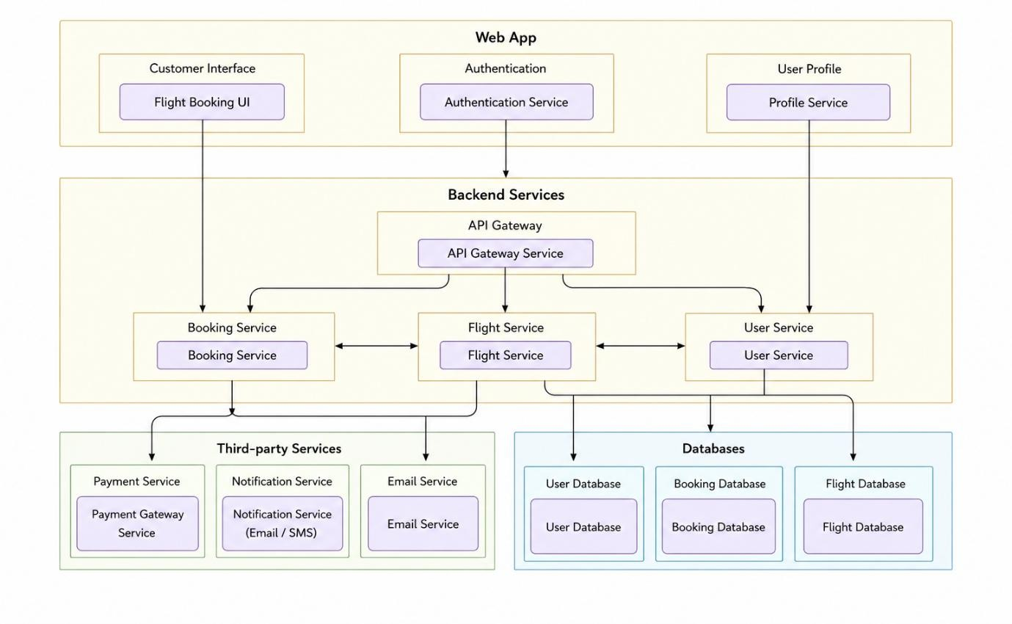
In this architecture, the flow begins with a user (represented by the “User” node) interacting with the Flight Booking System through the frontend interface (represented by the “Frontend

Application” node). The frontend is developed using React.js and provides a user-friendly interface where users can search for flights, view available options, and book tickets.
The user initiates an action such as searching for flights by entering details like source, destination, and travel date. This request is sent from the frontend to the backend server (represented by the “Backend Server” node) through REST API calls.
The backend, built using Node.js and Express.js, acts as the core processing unit of the system. It handles all business logic, including user authentication, flight search processing, booking management, and validation of user inputs. When a request is received, the backend processes it and determines the appropriate operation to perform.
For flight search operations, the backend communicates with the central database (represented by the “Database” node) to retrieve available flight details such as airline name, departure time, arrival time, and ticket price. The database is implemented using MongoDB, which stores structured data related to users, flights, bookings, and tickets.
In addition to handling flight data, the backend also manages booking transactions. When a user confirms a booking, the backend stores the booking details securely in the database, including passenger information, selected flight details, booking status, and timestamps.
The system may also include a payment service (represented by the “Payment Gateway” node) for processing online transactions. When a user proceeds with payment, the backend securely communicates with the payment gateway to complete the transaction and update the booking status accordingly.
Furthermore, the architecture may include a notification service (represented by the “Notification Service” node) to send booking confirmations, alerts, and updates to users via email or SMS.
Once the backend completes processing the request, it sends a response back to the frontend.
The frontend then displays the results to the user, such as available flights, booking confirmation details, or error messages.
The architecture ensures a clear separation of concerns:
- The frontend handles user interaction and presentation.

- The backend manages application logic and API processing.

- The database ensures persistent data storage.
- External services like payment and notifications enhance system functionality.
Additionally, security mechanisms such as JWT authentication, data validation, and secure API communication are implemented to protect user data and ensure safe transactions.
This layered architecture improves scalability, maintainability, and performance of the system. It allows the application to handle multiple users efficiently and supports future enhancements such as real-time flight tracking, seat selection, and advanced analytics.

ER DIAGRAM
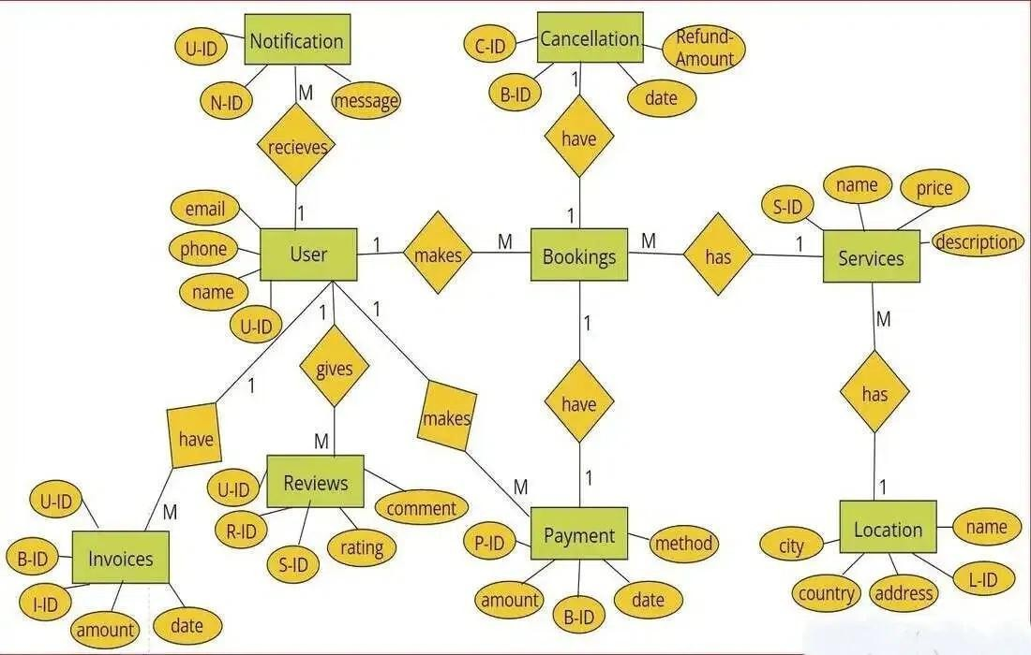
The Entity-Relationship (ER) diagram for the Flight Booking System represents the structure of the database and illustrates how different entities are related to each other. It provides a
clear visualization of how users interact with flights, bookings, tickets, and payments within the system.

Entities:

User:
Represents the customer using the system to search and book flights. Attributes:
  - User_ID (Primary Key)
  - Name
  - Email
  - Password
  - Phone_Number

Flight:
Represents available flights in the system. Attributes:
  - Flight_ID (Primary Key)
  - Airline_Name

  - Source
  - Destination
  - Departure_Time
  - Arrival_Time
  - Price

Booking:

Represents a reservation made by a user for a flight. Attributes:
  - Booking_ID (Primary Key)
  - User_ID (Foreign Key)

  - Flight_ID (Foreign Key)

  - Booking_Date
  - Seat_Number
  - Status

Ticket:
Represents the confirmed ticket generated after booking. Attributes:
  - Ticket_ID (Primary Key)
  - Booking_ID (Foreign Key)
  - Ticket_Number
  - Travel_Date

Payment:
Represents payment details associated with bookings. Attributes:
  - Payment_ID (Primary Key)
  - Booking_ID (Foreign Key)
  - Amount
  - Payment_Method
  - Payment_Status

Admin:

Represents the administrator who manages the system. Attributes:
  - Admin_ID (Primary Key)
  - Name

  - Email

  - Password

Relationships:
  - User → Booking (1:M):
A single user can make multiple bookings, but each booking belongs to one user.

Flight → Booking (1:M):
A flight can have multiple bookings, but each booking is for one flight.

Booking → Ticket (1:1):
Each booking generates exactly one ticket.

Booking → Payment (1:1):
Each booking is associated with one payment.

Admin → Flight (1:M):
Admin manages multiple flights including adding, updating, and deleting flight records.

Attributes Explanation:
Each entity consists of attributes that define its properties:
  - User stores login and personal information
  - Flight stores travel-related details
  - Booking links users and flights
  - Ticket confirms travel details
  - Payment stores transaction information

Primary Keys:
Primary keys uniquely identify each entity:
  - User_ID

  - Flight_ID

  - Booking_ID
  - Ticket_ID
  - Payment_ID
  - Admin_ID

Foreign Keys:
Foreign keys establish relationships between entities:

  - Booking → User_ID
  - Booking → Flight_ID
  - Ticket → Booking_ID
  - Payment → Booking_ID
The ER diagram provides a structured and logical representation of the Flight Booking System database. It clearly shows how users, flights, bookings, tickets, and payments are interconnected. This design ensures efficient data storage, minimizes redundancy, and supports scalability for future enhancements.

KEY FEATURES:
The Flight Booking System offers a wide range of features designed to simplify and enhance the process of searching, booking, and managing flight tickets. These features ensure a smooth, secure, and user-friendly experience for both customers and administrators.

User Registration and Authentication:
The system allows users to create accounts by providing basic details such as name, email, and password. Secure authentication mechanisms are implemented to protect user data and ensure safe login access. Users can manage their profiles and update personal information when required.

Flight Search Functionality:

Users can search for flights by entering travel details such as departure city, destination, and travel date. The system processes the request and displays a list of available flights that
match the user’s criteria.

Flight Comparison:
The application enables users to compare different flight options based on important
parameters such as price, departure time, arrival time, and airline. This helps users make informed decisions and choose the most suitable flight.

Online Ticket Booking:
Users can select a preferred flight and proceed with booking by entering passenger details. The system processes the booking and confirms the reservation instantly.

Booking Management:
The system maintains a record of all bookings made by users. Users can view their booking history, check upcoming trips, and manage their reservations efficiently.

Payment Integration:
The system supports secure online payment options, allowing users to complete transactions using debit cards, credit cards, or digital payment methods. Payment status is recorded and linked to bookings.

Ticket Generation:
After successful booking and payment, the system generates a digital ticket containing all necessary travel details such as flight information, passenger details, and booking ID.

Admin Control Panel:
Administrators have access to a dedicated dashboard where they can manage flight details, including adding new flights, updating schedules, and removing outdated entries. They can also monitor user bookings and system activity.

Real-Time Data Handling:

The system dynamically retrieves and displays updated flight information, ensuring users receive accurate and current data while searching and booking flights.

Security and Data Protection:
The application implements security measures such as authentication, data validation, and secure API communication to protect user information and ensure safe transactions.

User-Friendly Interface:
The frontend is designed with a clean and responsive interface, making it easy for users to navigate, search flights, and complete bookings without confusion.

Scalability and Performance:
The system is built using the MERN stack, which allows it to handle multiple users efficiently and supports future enhancements such as seat selection, live tracking, and advanced analytics.

ROLES AND RESPONSIBILITIES:
The Flight Booking System involves multiple users interacting with the application, each having specific roles and responsibilities. The two primary roles in the system are User (Customer) and Admin (Administrator).

User (Customer):

Registration and Account Management:
Users are responsible for creating an account by providing accurate personal details such as name, email, and password. They must ensure that their login credentials are kept secure and update their profile information when necessary.

Flight Search and Selection:

Users can search for flights based on their travel preferences such as source, destination, and travel date. They are responsible for reviewing the available options and selecting the most suitable flight based on timing, pricing, and airline.

Booking and Reservation:
Users are responsible for entering correct passenger details while booking a flight. They must carefully review the booking information before confirming the reservation to avoid errors.

Payment Responsibility:
Users must complete the payment process using the available payment methods. They are responsible for ensuring that the payment details provided are accurate and secure.

Booking Management:
Users can view their booking history and manage upcoming trips. They may cancel or modify bookings (if the system supports it) and keep track of their travel plans.

Communication and Support:
Users may contact customer support or use system-provided communication channels for queries, booking issues, or assistance. They should follow the guidelines while raising concerns.

Feedback and Reviews:
Users can provide feedback about their booking experience. This helps improve the system and assists other users in making better decisions.
Admin (Administrator):

System Management:
The admin is responsible for overseeing the overall functioning of the Flight Booking System. This includes maintaining system performance, ensuring uptime, and managing configurations.

User Management:

Admins manage user accounts by verifying registrations, handling login issues, and taking necessary actions such as suspending or deleting accounts in case of misuse.

Flight Management:
Admins are responsible for adding new flight details, updating schedules, modifying pricing, and removing outdated flights. They ensure that all flight data in the system is accurate and up-to-date.

Booking Monitoring:

Admins monitor all bookings made in the system. They can view booking details, track transaction statuses, and resolve issues related to reservations.

Payment and Transaction Management:
Admins oversee payment records and ensure that all transactions are processed correctly. They may handle failed transactions or refund processes if required.

Security and Data Management:
Admins ensure that user data and system data are secure. They implement security policies, monitor unauthorized access, and maintain data integrity.

System Updates and Maintenance:
Admins are responsible for updating the system with new features, fixing bugs, and ensuring smooth operation of the application.

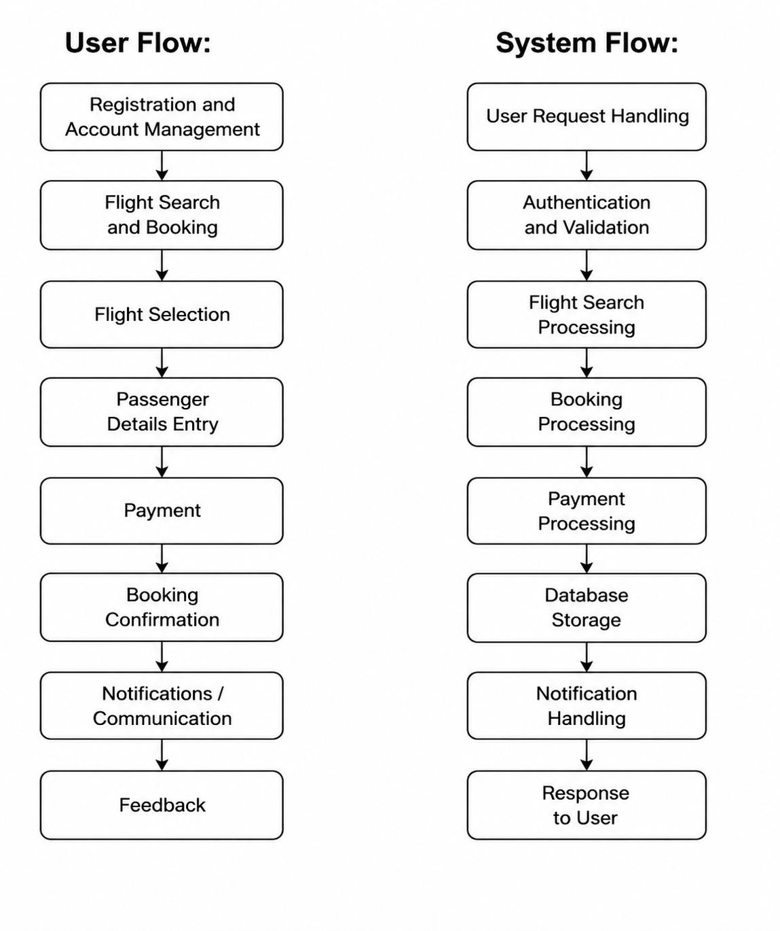
Customer Flow
- Registration & Account – Create an account, log in securely, and manage personal details such as name, email, and travel information.

- Flight Search & Booking – Search for available flights based on source, destination, and travel date, and proceed with booking the selected flight.
- Flight Selection – View available flight options with details like airline, timing, and price, and choose the most suitable flight.
- Passenger Details Entry – Enter passenger information such as name, age, and contact details required for booking.
- Payment – Make secure online payments using available methods such as debit/credit cards or digital payment options.
- Booking Confirmation – Receive confirmation (ticket/booking ID) after successful booking of the flight.
- Communication / Notifications – Receive updates regarding booking status, flight details, and reminders via email/SMS.
- Feedback – Provide feedback about the booking experience to improve the system.

System Flow
- User Request Handling – The system receives a request from the user such as searching for flights, booking tickets, or making a payment through the frontend interface.
- Authentication & Validation – The system verifies user credentials and validates the input data (such as travel details and passenger information) to ensure correctness and security.
- Flight Search Processing – The system processes the search request and retrieves relevant flight data based on source, destination, and travel date.
- Booking Processing – After the user selects a flight, the system processes the booking by validating availability and preparing booking details.
- Payment Processing – The system securely handles payment transactions and confirms the payment status before proceeding further.

- Database Storage – All booking, user, and payment details are stored securely in the database for future reference and management.
- Notification Handling – The system generates notifications such as booking confirmation, ticket details, and reminders, and sends them via email or SMS.
- Response to User – Finally, the system sends the processed response back to the user interface, displaying booking confirmation or requested information.

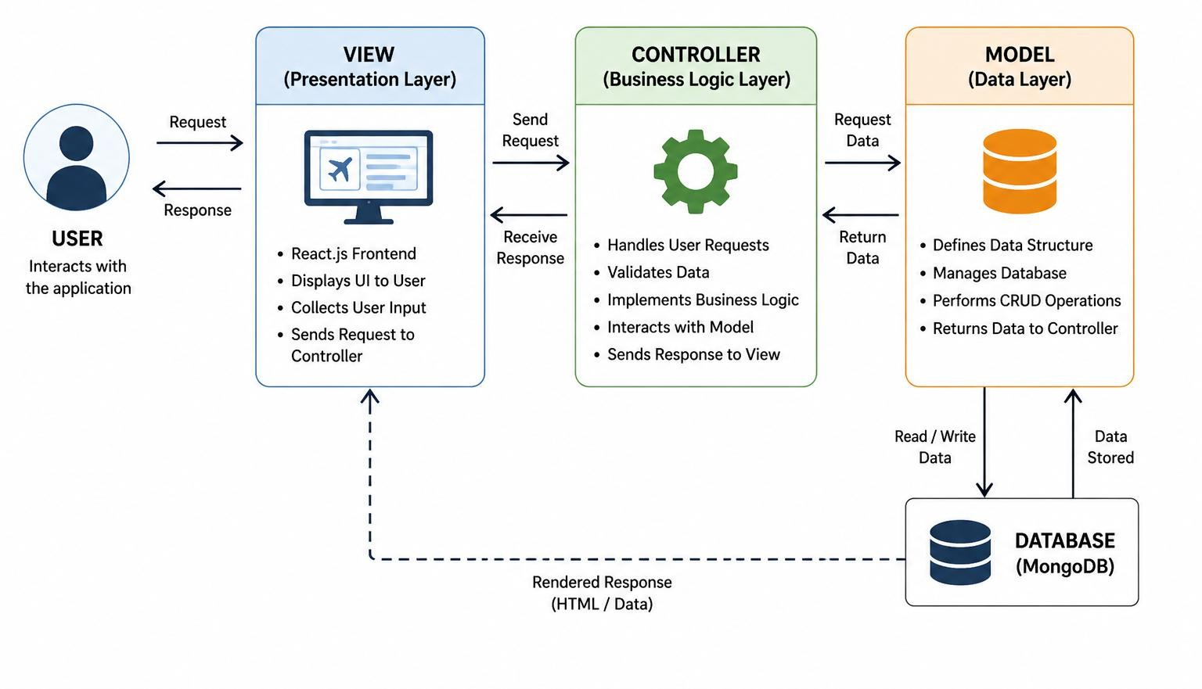
MVC PATTERN:

The Flight Booking System follows the Model-View-Controller (MVC) architectural pattern, a widely used software design approach that separates an application into three
interconnected layers. This separation improves modularity, scalability, and maintainability of the system.

Model Layer (Data Layer):
The Model layer is responsible for handling all data-related operations in the system. It defines the structure of the database and manages interactions with the database.

In the Flight Booking System, the Model layer includes:

  - User Model – stores user details such as name, email, and password
  - Flight Model – stores flight information such as airline, source, destination, timing, and price
  - Booking Model – stores booking details linking users and flights
  - Payment Model – stores transaction and payment details
  - Ticket Model – stores generated ticket information
The models are implemented using Mongoose, which provides a schema-based structure for MongoDB and ensures data consistency and validation.

Controller Layer:
The Controller layer acts as an intermediary between the View and the Model. It handles incoming requests, processes business logic, and interacts with the Model layer to perform required operations.
In the Flight Booking System, the Controller layer performs tasks such as:
  - Handling user registration and login requests
  - Processing flight search queries

  - Managing booking and reservation logic
  - Handling payment processing
  - Sending responses back to the frontend
Controllers ensure that all application logic is properly executed before returning results to the user.

View Layer (Routing / Presentation Layer):

The View layer represents the user interface of the application. In this project, it is implemented using React.js, which provides a dynamic and responsive frontend.
The View layer is responsible for:
  - Displaying flight search results
  - Showing booking forms and payment pages
  - Presenting booking confirmation and ticket details
  - Interacting with backend APIs using HTTP requests
In the backend, the View is also associated with routing, where API endpoints (GET, POST, PUT, DELETE) are defined to handle different client requests.

Advantages of Using MVC in This Project:
- Separation of Concerns – Each layer has a distinct responsibility, making the system easier to understand and maintain.
- Scalability – New features such as seat selection or live tracking can be added easily without affecting existing components.
- Reusability – Code in controllers and models can be reused across different parts of the application.
- Testing – Each layer can be tested independently, improving reliability.
- Maintainability – Changes in one layer (e.g., UI updates) do not affect other layers.
- Collaboration-Friendly – Multiple developers can work on frontend, backend, and database simultaneously.
The MVC pattern ensures a well-structured architecture for the Flight Booking System by separating data handling, business logic, and user interface. This results in a scalable,
maintainable, and efficient application that can handle real-world booking operations effectively.

Project Setup and Configuration.
- Creating project folder
- Create a new folder with < Flight-booking >
- Inside that folder create two new folders.
- Name one as **Frontend**.
- Name another one as **Backend**.
- Now open that folder in VS Code.
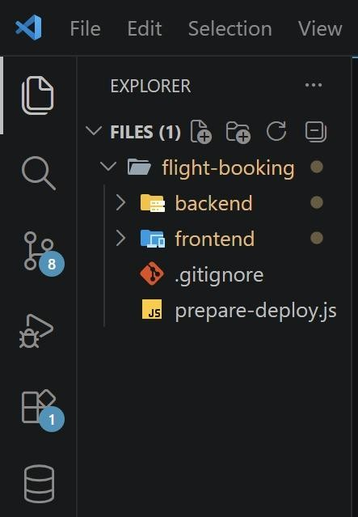
  - Client setup (installing react app)
- Open the Client folder in the terminal of VScode.
  - npm create vite@latest template react
- Select React framework from the given options.
  - Select a framework:
  - │ React
- Select JavaScript variant from the given options.
  - Select a variant:
  - │ JavaScript
- Now let’s navigate to the frontend folder by giving the following command.

  - cd Frontend
- To install all the packages, run the following command.
  - npm install
- To start the React server type the following command.
  - npm run dev

- Server setup (npm init)
- Open Server folder in terminal of VScode.
  - npm init -y
- Create files:
  - server.js
- Create folders:
  - models
  - controllers
  - Routes

BACKEND DEVELOPMENT:
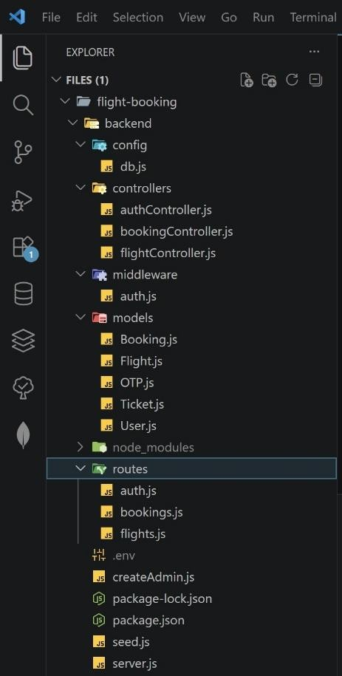

config

  - db.js → Handles database configuration and establishes connection with MongoDB using Mongoose.
Ensures the backend can interact with the database efficiently.

controllers
  - authController.js → Manages user authentication operations such as registration, login, and OTP verification.
  - bookingController.js → Handles booking-related operations like creating bookings, viewing bookings, and managing user reservations.
  - flightController.js → Manages flight-related functionalities such as adding flights, updating flight details, searching flights, and availability.

middleware
  - auth.js → Middleware for authentication and authorization using JWT tokens. Protects routes and ensures only authenticated users can access secure APIs.

models

  - User.js → Schema for storing user details like name, email, password, etc.
  - Flight.js → Schema for storing flight information such as source, destination, timings, and seat availability.
  - Booking.js → Schema for managing booking records including user ID, flight ID, and booking status.
  - Ticket.js → Stores generated ticket details after successful booking.
  - OTP.js → Handles OTP generation and verification for secure login/signup.

routes
  - auth.js → Defines API routes for authentication (login, register, OTP verification).
  - bookings.js → Contains routes related to booking operations.
  - flights.js → Contains routes for flight operations like search, add, update, and delete flights.

root files

  - server.js → Entry point of the application. Initializes Express server, connects middleware, and links routes.
  - .env → Stores environment variables like database URI, JWT secret, and API keys securely.
  - createAdmin.js → Script to create an admin user manually in the database.
  - seed.js → Used to insert sample data (like flights) into the database for testing.
  - package.json → Contains project metadata, dependencies, and scripts.
  - package-lock.json → Maintains exact dependency versions for consistency.

DATABASE DEVELOPMENT:
- Configure MongoDB:
  - Install Mongoose.
In your Node.js project directory, run: npm install mongoose
  - Create database connection.
  - Create Schemas & Models.

Create Database connection
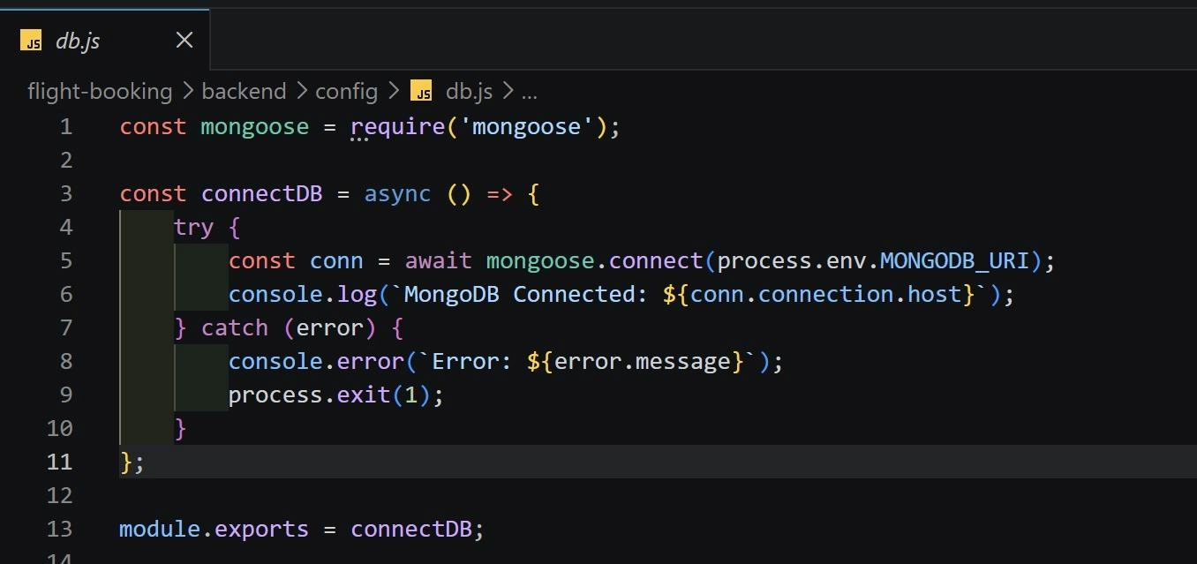
- User.js - Schema for storing user details like name, email, password, etc.
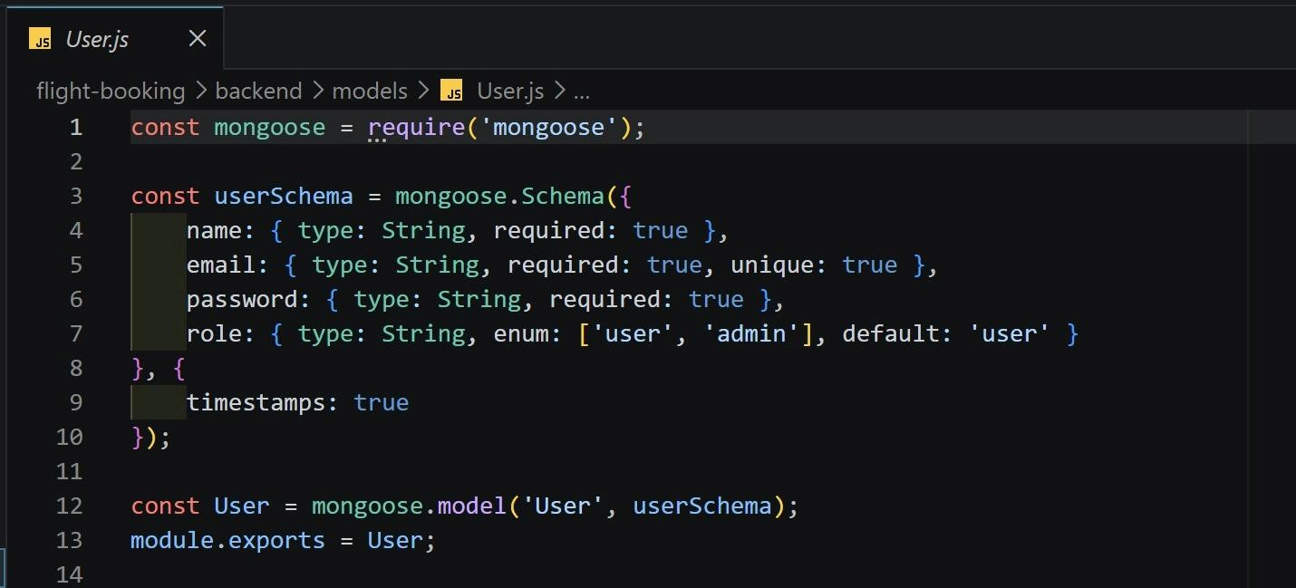
- Booking.js -Managing booking records including user ID, flight ID, and booking status.
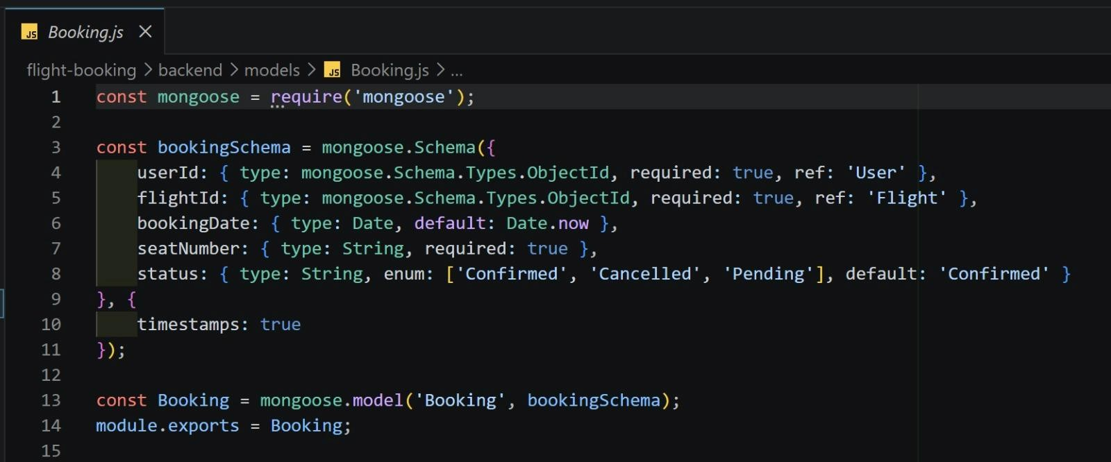

- Flight.js → Schema for storing flight information such as source, destination, timings, and seat availability.
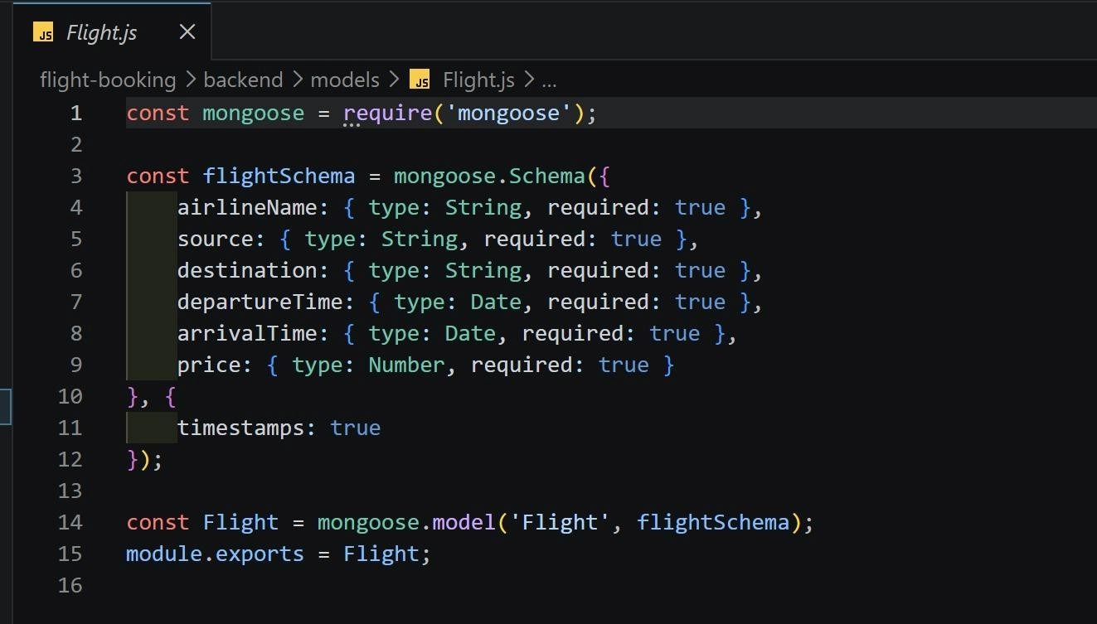

- OTP.js → Handles OTP generation and verification for secure login/signup.

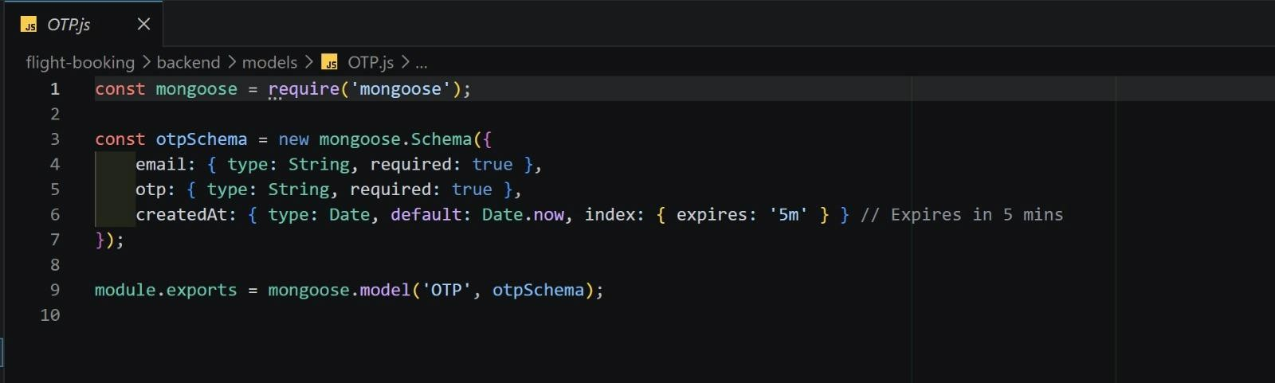

FRONT-END DEVELOPMENT:
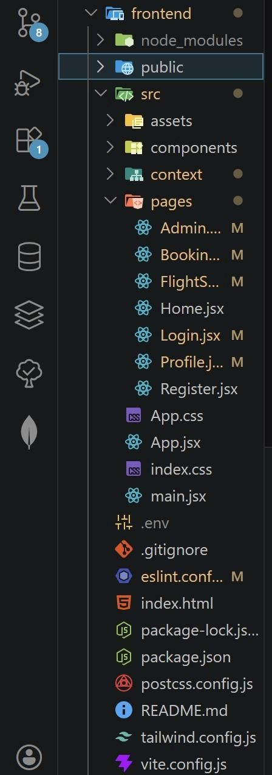

public
  - Contains static files like images, icons, and the main HTML file.
  - index.html → Entry HTML file where the React app is mounted.

src (Main Source Folder)

`. assets
  - Stores static resources like images, logos, icons, and styles.
`. components
  - Contains reusable UI components (like Navbar, Footer, Flight Card, etc.).
  - Helps in modular and clean UI design.

`. context
  - Manages global state using React Context API.
  - Used for storing user login data, tokens, and shared state across components.
`. pages
Each file represents a separate page in the application:
  - Home.jsx → Landing page with flight search options (source, destination, date).
  - Login.jsx → Handles user login functionality.
  - Register.jsx → Allows new users to create an account.
  - Flights.jsx → Displays available flights based on search results.
  - Booking.jsx → Handles ticket booking process.
  - Profile.jsx → Shows user details and booking history.
  - Admin...jsx → Admin dashboard for managing flights and system operations.
) ‘ App.jsx
  - Main component that defines routing between pages using React Router.
  - Acts as the central structure of the UI.
‘) main.jsx
  - Entry point of the React application.
  - Renders the App component into the DOM.

‘ ) App.css / index.css
  - Used for styling the application.
  - Includes global styles and component-level design.

Configuration Files
  - .env → Stores environment variables like API base URL.
  - vite.config.js → Configuration for Vite (fast build tool).
  - tailwind.config.js → Configuration for Tailwind CSS (utility-first styling).
  - postcss.config.js → Used for CSS processing with Tailwind.
  - eslint.config.js → Maintains code quality and consistency.

Dependencies
  - package.json → Contains project dependencies (React, Vite, Tailwind, etc.) and scripts.
  - package-lock.json → Locks dependency versions.

Output screenshots:
- Landing Page:


- Register.jsx
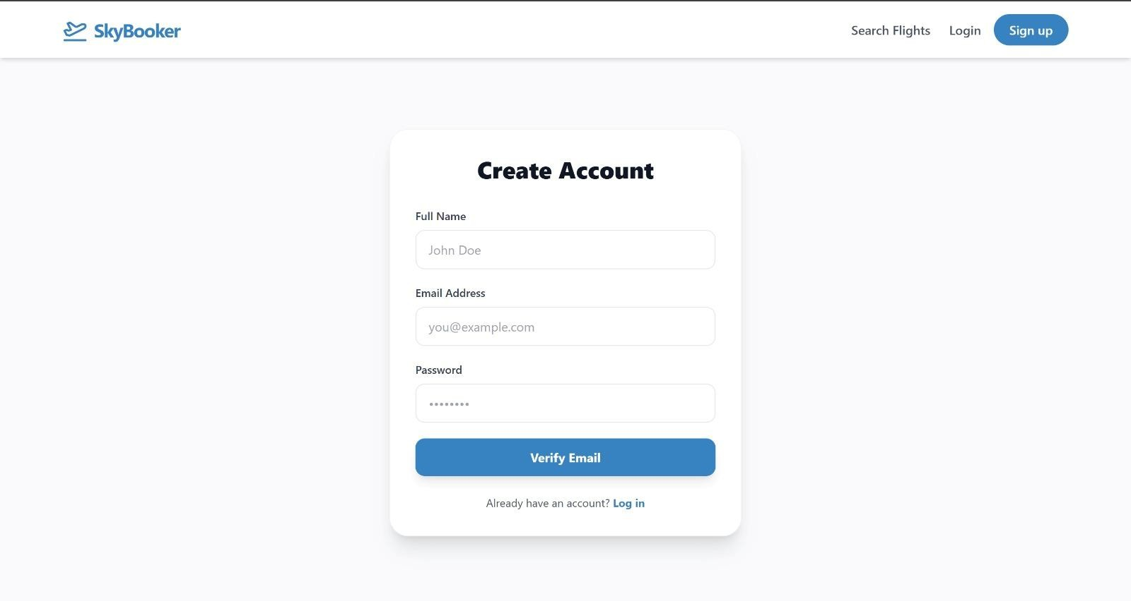

- Login.jsx

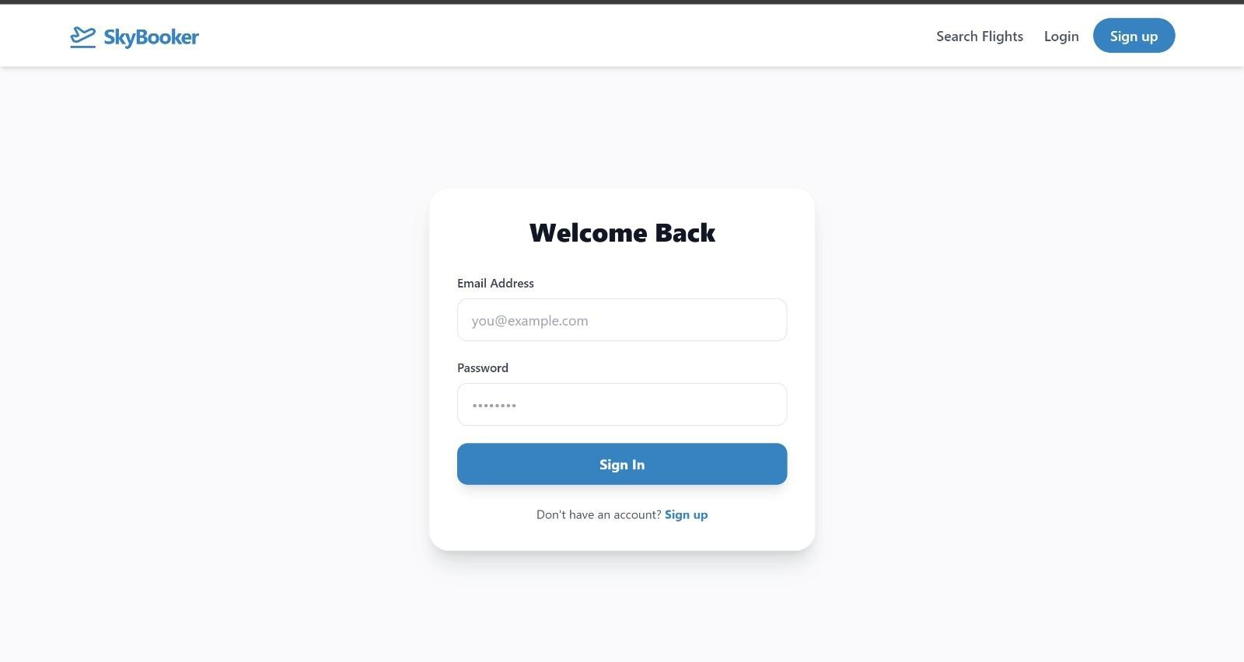

- FlightSearch.jsx

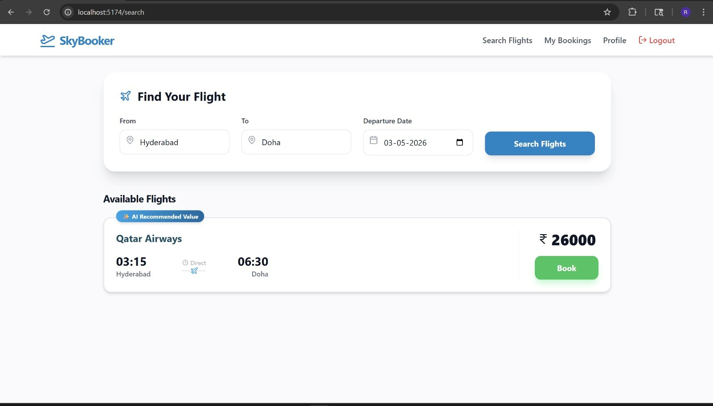

- Seat Selection
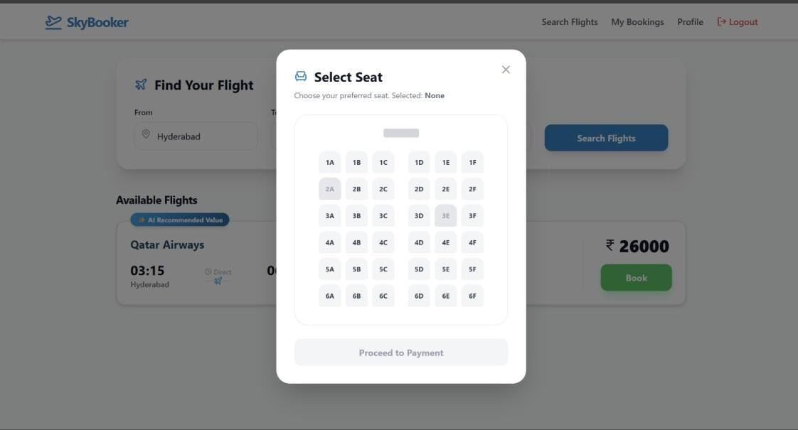

- My bookings page

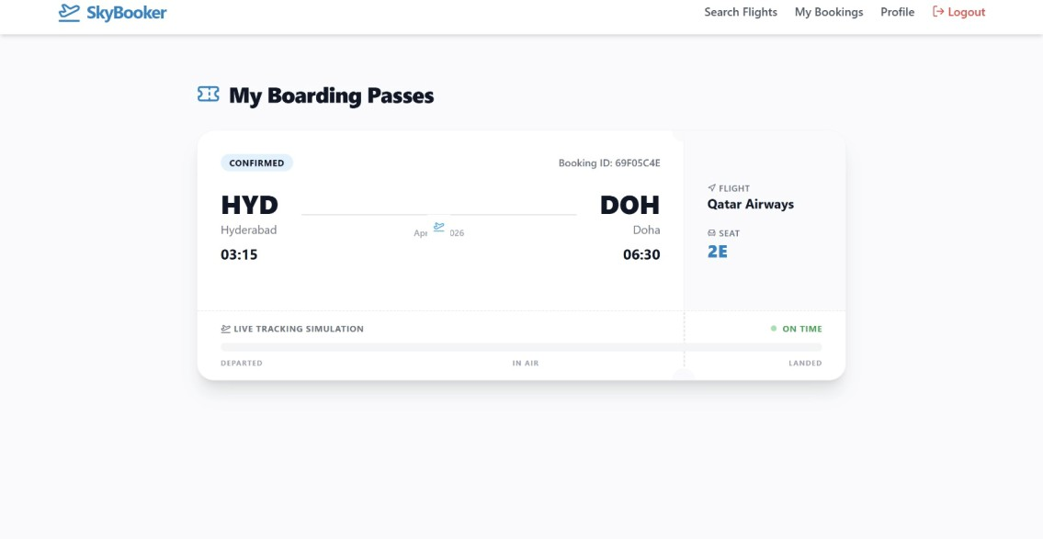

- admin Dashboard
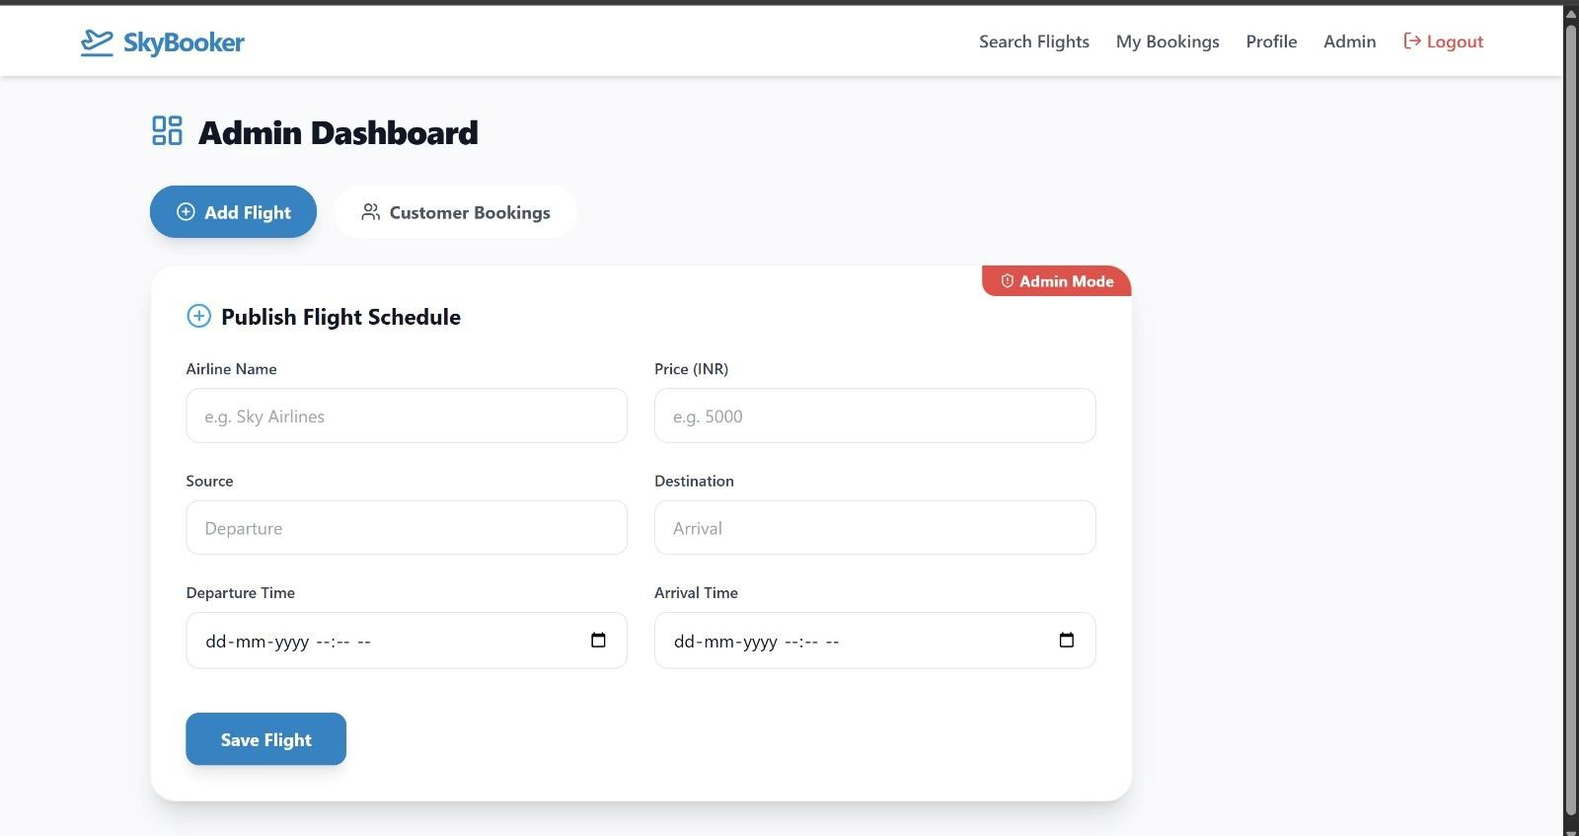

Video demonstration

https://drive.google.com/file/d/1av6lQDoALveOdiuKg4XOKh41CKDUz6bb/view?usp=drivesdk

